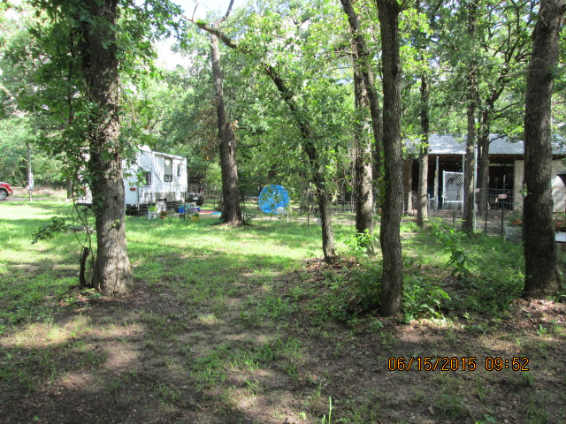
Come build your very own dream home here on this beautiful 1 acre lot in Hearne. RV can convey with property for extra $10,000. Property is close to great restaurants and 20 minutes from Bryan/College Station.
Listed at $25,000

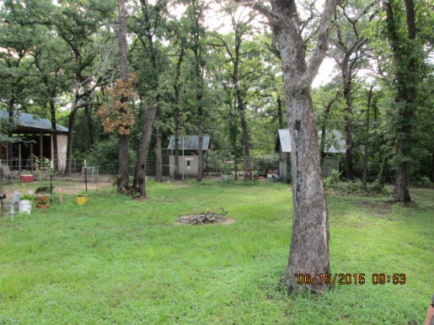
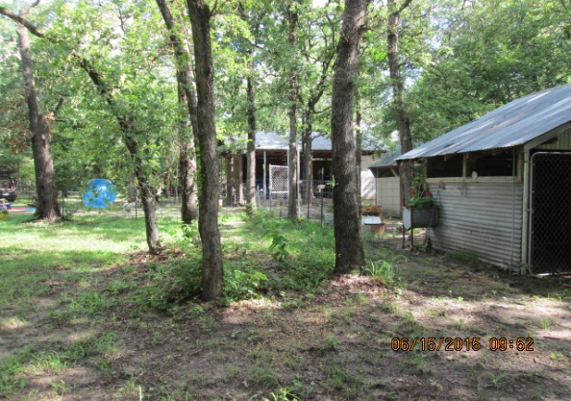

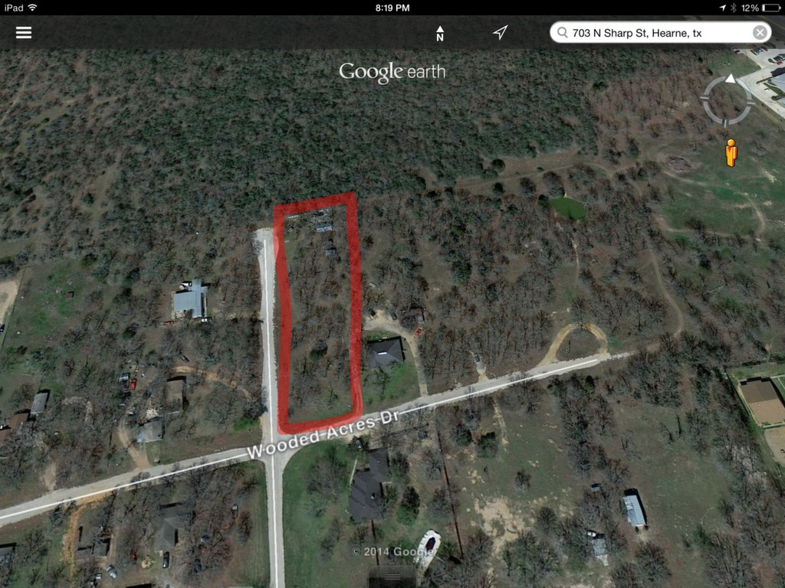
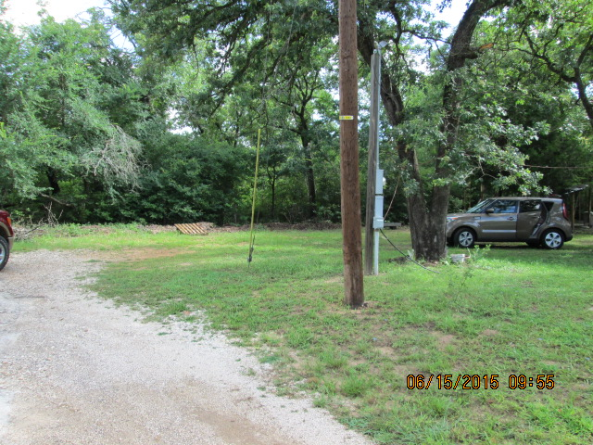
Amenities:
1 acre
Paved road
City Sewer
2 city water meters
No Mobile Homes
Close to Bryan/College Station
As a Licensed Texas Realtor®, I am required to provide each contact with the following information. Please review the link: http://www.trec.state.tx.us/pdf/contracts/OP-K.pdf

